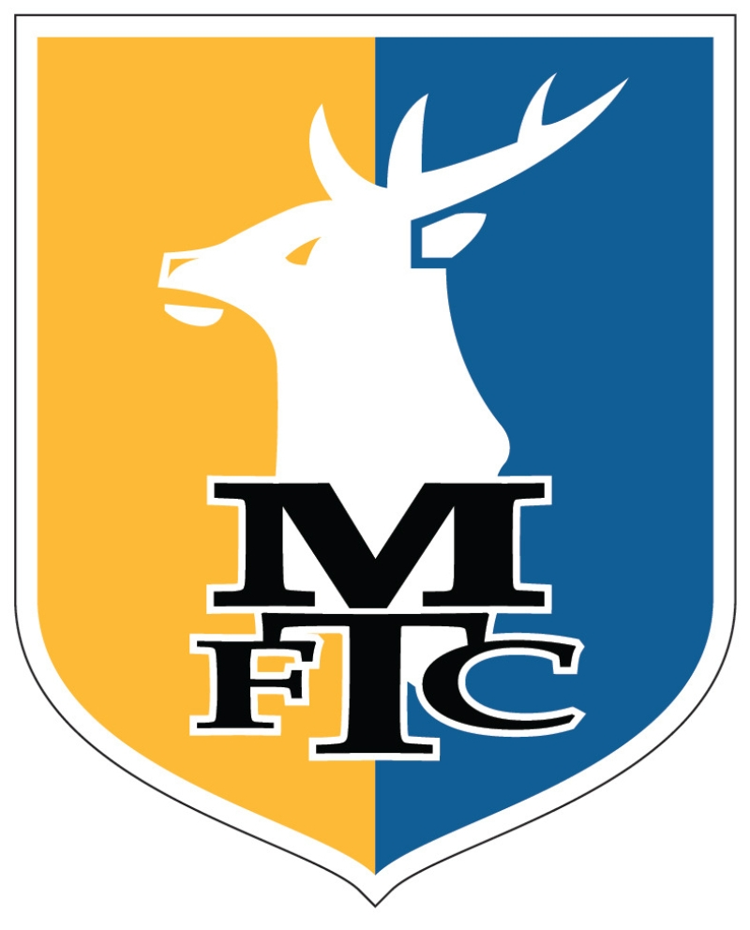
PERSONAL DETAILS:
MANSFIELD TOWN FC 2021/22
SEASON TICKET APPLICATION FORM

No

Yes
I am an existing season
ticket holder (delete as appropriate):

Title:
Forename:
Surname:
Date of Birth:
Address:

Postcode:
Mobile No:
Home Tel:
Email Address:
Membership No:
(If Applicable)
Stand:
Block:
Row:
Seat:
SEASON TICKET PRICES 2021-22
*Senior citizens must be aged 65 or over on 06/08/2021. Existing senior citizen ticket holders aged under 65 can still renew at the senior rate. **Young adults must be aged 18-21 on 06/08/2021 ****Juniors must be aged 13-17 on 06/08/2021 ***Juniors must be aged 7-12 on 06/08/2021. Disabled supporters may pay the age-related price for the relevant season ticket. Those in receipt of the higher DLA will be entitled to a carer’s season ticket free of charge once proof of eligibility is provided.
Adult  Renewal: £250  Early Bird: £325  Regular: £375 | Senior Citizen*  (65 or over)  Renewal: £200  Early Bird: £280  Regular: £295 | Young Adults**  (18-21)  Renewal: £160  Early Bird: £170  Regular: £180 | Junior****  (13-17)  Renewal: £90  Early Bird: £90  Regular: £100
Junior***  (7-12)  Renewal: £45  Early Bird: £45  Regular: £50 | 6 & UNDER  FREE  (Must be accompanied by a paying adult) | Disabled & Carer  (As applicable)

TICKET TYPE: (Please highlight or delete as appropriate)

Young Adult

Senior Citizen

Adult

Junior (13-17)

Junior (7-12)

6 & Under (FREE)

Disabled & Carer
MARKETING PREFERENCE:
TERMS & CONDITIONS
For the avoidance of doubt, renewal prices for 2021-22 relate only to supporters who remained a season ticket holder from 2020-21 for its entirety.
Season ticket cards will be made available by collection only unless delivery postage is paid (£5.95). Proof of age will be required when purchasing your season ticket. Proof of higher DLA will be required for disabled supports who require a free carer ticket.
By applying for a season ticket card, you are indicating that you have read, understood accepted and agreed to abide by the ground rules and regulations. Copies will be posted at various points around the ground and pretend copies are available on request. All areas of the ground are strictly non-smoking areas. The Club reserves the right to amend the date, time and venue of any publicised fixture for any reason without prior notification. From time to time, the Club may make special offers available to supports regarding ticket prices. Season tickets are issued for your sole use only and are not transferable or for resale.
Similarly, the unauthorised sale of any tickets may be illegal under section 166 of the Criminal Justice and Public Order Act 1994.
in the event that social distancing measures are introduced on a match day at One Call Stadium, we will try to keep people as close to their original seats as possible, however, social distancing requirements will take priority.

We would like to send you details of our exclusive offers and the latest information from Mansfield Town Football Club by email, post, SMS, phone and other electronic means. We will always treat your personal details with the utmost care and will never sell them to other companies for marketing purposes. Please let us know if you would like us to contact you or not by selecting one of the options below (by ticking your selection)
[ ] Yes please, I would like to hear about offers and services
[ ] No thanks, I do not want to hear about offers and services
One Call Stadium - Quarry Lane - Mansfield - NG18 5DA - Tel: 01623 482482
Name: | Membership No: | Stand: | Block: | Row: | Seat:

COVID-19 DATA COLLECTION:
Have you been vaccinated against COVID-19? (Delete as appropriate)
[ ] No
[ ] I’ve received the first vaccination
[ ] I’ve received the second vaccination
Have you had a positive COVID-19 test in the last three months?
[ ] Yes
[ ] No
Have you recovered from COVID-19 in the last six months?
[ ] Yes
[ ] No

