Mansfield Town Football Club
Youth Performance Trials 2022/23
Player Profile Form

PLAYER NAME |  |  | DOB
CURRENT SCHOOL YEAR |  | PLAYER AGE GROUP (Upcoming Season 2022/23)
ADDRESS
PARENT/GUARDIAN NAME
PARENT/GUARDIAN EMAIL
CONTACT NUMBER
PLAYER POSITION
PLAYER ILLNESS/INJURY INFO
CURRENT/PREVIOUS CLUBS
ACADEMY/PROFESSIONAL CLUB EXPERIENCE
ANY ADDITIONAL INFO COACHES MAY NEED

Closing date Sunday 29 May 2021. Applications after this date will not be accepted.

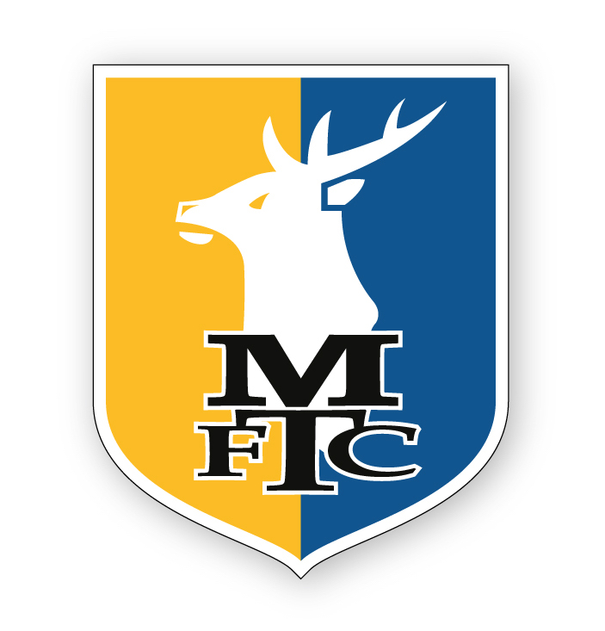
Once complete, send application form to fred.coggeran@mansfieldtown.net Please check that the information given is correct including school year and age group in which your child is CURRENTLY playing at.

Youth Performance Trials - Grassroots Application Form

PLEASE NOTE: THIS APPLICATION IS FOR OUR YOUTH PERFORMANCE SQUADS WHO PLAY IN GRASSROOT LEAGUES AND NOT THE ACADEMY.

